**//31139- Durvesh- CNLB4 (UDP using Java)**

**Writeup**

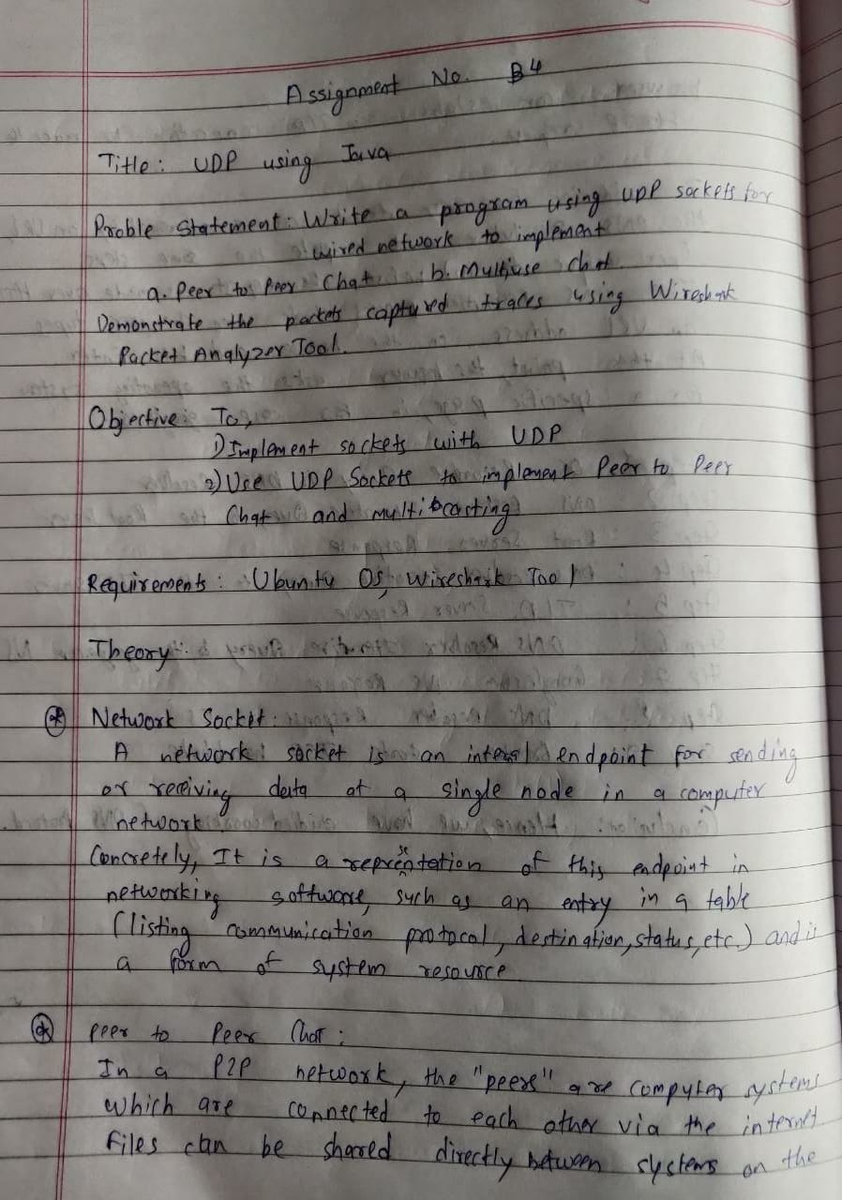

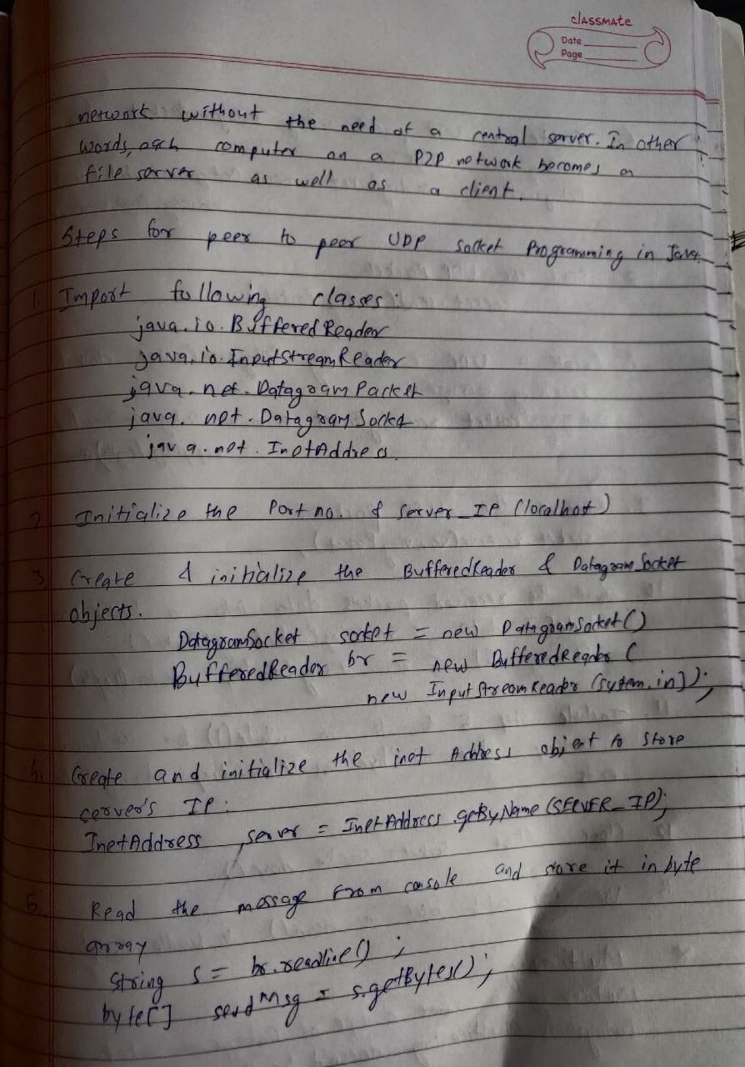

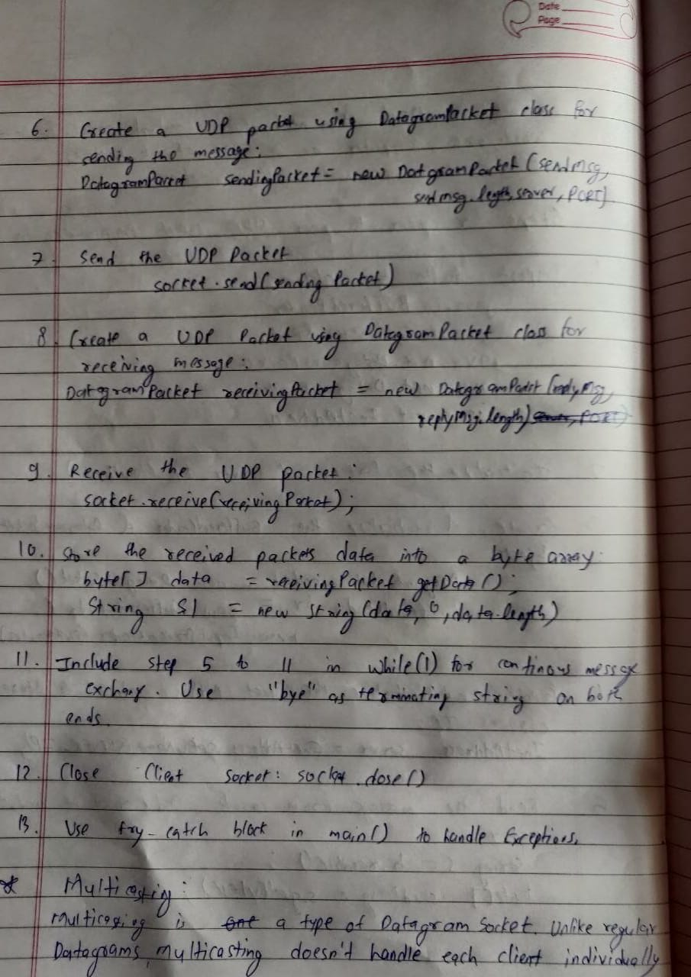

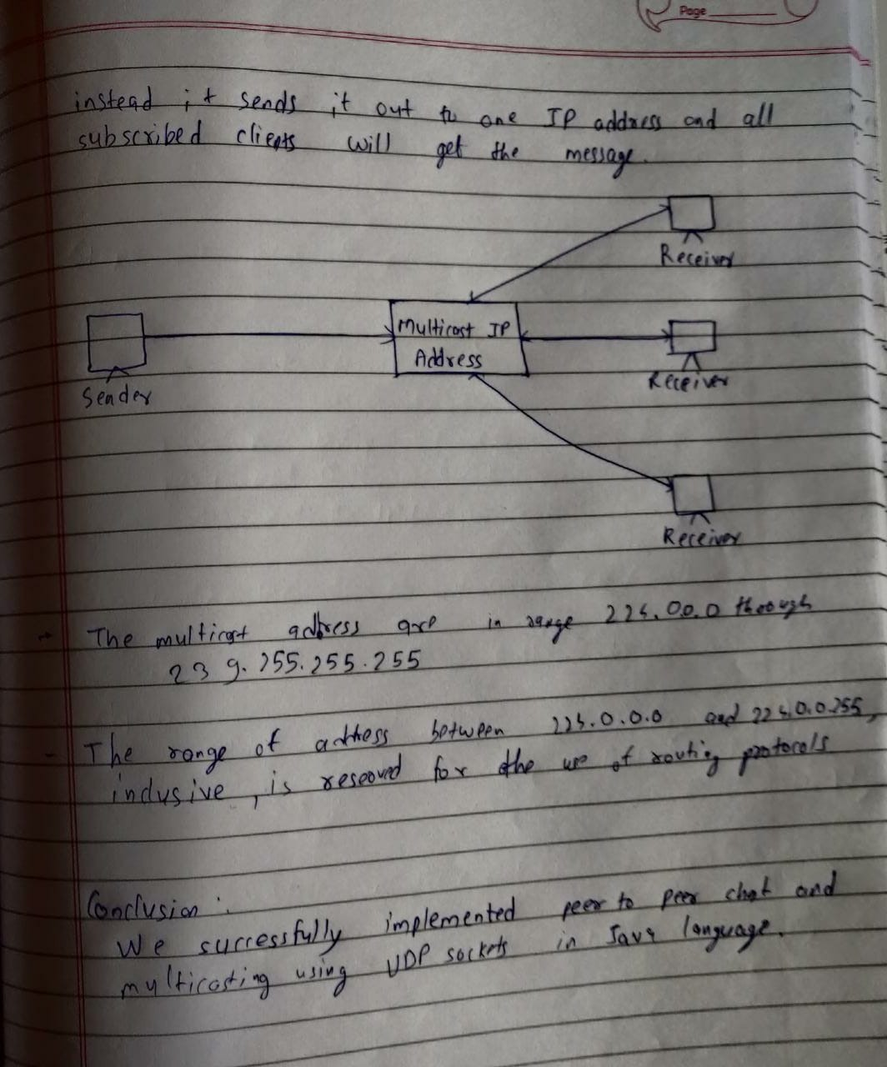

**Code**

**------P2pclient.java**

package udp;  
  
import java.io.BufferedReader;  
import java.io.IOException;  
import java.io.InputStreamReader;  
import java.net.DatagramPacket;  
import java.net.DatagramSocket;  
import java.net.InetAddress;  
import java.net.SocketException;  
import java.nio.charset.StandardCharsets;  
  
public class P2pclient {  
 public static void main(String[] args) throws SocketException, IOException {  
  
 BufferedReader clientRead =new BufferedReader(new InputStreamReader(System.*in*));  
  
 InetAddress IP = InetAddress.*getByName*("127.0.0.1");  
  
 DatagramSocket clientSocket = new DatagramSocket();  
 while(true) //true  
 {  
 byte[] sendbuffer = new byte[1024];  
 byte[] receivebuffer = new byte[1024];  
  
 System.*out*.print("\n\nClient: ");  
 String clientData = clientRead.readLine();  
 sendbuffer = clientData.getBytes();  
 DatagramPacket sendPacket =  
 new DatagramPacket(sendbuffer, sendbuffer.length, IP, 2604);  
 clientSocket.send(sendPacket);  
 if(clientData.equalsIgnoreCase("bye"))  
 {  
 System.*out*.println("\nConnection ended by client");  
 break;  
 }  
  
  
 DatagramPacket receivePacket =  
 new DatagramPacket(receivebuffer, receivebuffer.length);  
 clientSocket.receive(receivePacket);  
 receivebuffer = receivePacket.getData();  
 String serverData = new String(receivebuffer , StandardCharsets.*UTF_8*);  
  
 System.*out*.print("\nServer: " + serverData);  
 if(serverData.equals("bye"))  
 {  
 System.*out*.println("\n\nConnection ended by server...");  
 break;  
 }  
  
 }  
 clientSocket.close();  
 }  
}

**-------P2pserver.java**

package udp;  
  
import java.io.BufferedReader;  
import java.io.IOException;  
import java.io.InputStreamReader;  
import java.net.DatagramPacket;  
import java.net.DatagramSocket;  
import java.net.InetAddress;  
import java.net.SocketException;  
import java.nio.charset.StandardCharsets;  
  
  
public class P2pserver {  
  
  
 public static void main(String[] args) throws SocketException, IOException {  
  
 DatagramSocket serverSocket = new DatagramSocket(2604);  
  
 while(true)  
 {  
 byte[] receivebuffer = new byte[1024];  
 byte[] sendbuffer = new byte[1024];  
 DatagramPacket recvdpkt = new DatagramPacket(receivebuffer, receivebuffer.length);  
 serverSocket.receive(recvdpkt);  
 receivebuffer = recvdpkt.getData();  
 InetAddress IP = recvdpkt.getAddress();  
 int portno = recvdpkt.getPort();  
 String clientdata = new String(receivebuffer , StandardCharsets.*UTF_8*);  
 if(clientdata.equals("bye"))  
 {  
 System.*out*.println("\n\nConnection ended by client...");  
 break;  
 }  
 System.*out*.println("\nClient : "+ clientdata);  
 System.*out*.print("\nServer : ");  
 BufferedReader serverRead = new BufferedReader(new InputStreamReader (System.*in*) );  
 String serverdata = serverRead.readLine();  
  
 sendbuffer = serverdata.getBytes();  
 DatagramPacket sendPacket = new DatagramPacket(sendbuffer, sendbuffer.length, IP,portno);  
 serverSocket.send(sendPacket);  
  
 if(serverdata.equalsIgnoreCase("bye"))  
 {  
 System.*out*.println("\nConnection ended by server...");  
 break;  
 }  
  
  
 }  
 serverSocket.close();  
 }  
  
}

**-------Multicastclient.java**

package udp;  
  
import java.io.BufferedReader;  
import java.io.IOException;  
import java.io.InputStreamReader;  
import java.net.DatagramPacket;  
import java.net.InetAddress;  
import java.net.MulticastSocket;  
import java.net.SocketException;  
import java.nio.charset.StandardCharsets;  
import java.net.*;  
public class Multicastclient{  
 public static void main(String args[]) {  
 try{  
 InetAddress group = InetAddress.*getByName*("225.4.5.6");  
 MulticastSocket multiSocket = new MulticastSocket(2604) ;  
 multiSocket.joinGroup(group);  
 byte[] buffer = new byte[1024];  
 DatagramPacket packet = new DatagramPacket(buffer, buffer.length);  
 while(true) {  
 multiSocket.receive(packet);  
 buffer = packet.getData();  
 String data = new String(buffer , StandardCharsets.*UTF_8*);  
 System.*out*.println("Server > "+ data);  
 if(data.equals("exit")){  
 System.*out*.println("\nServer connection terminated...");  
 break;  
 }  
 }  
 multiSocket.close();  
 }  
 catch (Exception e) {  
 e.printStackTrace();  
 }  
 }  
}

**-------Multicastserver.java**

package udp;  
import java.io.BufferedReader;  
import java.io.IOException;  
import java.io.InputStreamReader;  
import java.net.DatagramPacket;  
import java.net.MulticastSocket;  
import java.net.InetAddress;  
import java.net.SocketException;  
import java.util.Scanner;  
public class Multicastserver{  
 public static void main(String args[]) {  
 try {  
 InetAddress group = InetAddress.*getByName*("225.4.5.6");  
 MulticastSocket multiSocket= new MulticastSocket(2604) ;  
 multiSocket.joinGroup(group);  
 String data = "";  
 BufferedReader ip =new BufferedReader(new InputStreamReader(System.*in*));  
 while(!data.equals("exit")) {  
 System.*out*.println("Server > ");  
 data = ip.readLine();  
 DatagramPacket sendPacket = new  
 DatagramPacket(data.getBytes(),data.length(),group,2604);  
 multiSocket.send(sendPacket);  
 }  
 multiSocket.close();  
 System.*out*.println("\nSocket Closed...");  
 }  
 catch(Exception e){  
 e.printStackTrace();  
 System.*out*.println("ERROR");  
 }  
 }  
}

**Outputs**

